2022-23
ALABAMA HOSA Advisor of the Year
APPLICATION GUIDELINES

rEVISED July 13, 2022
ALABAMA HOSA
ADVISOR OF THE YEAR
APPLICATION
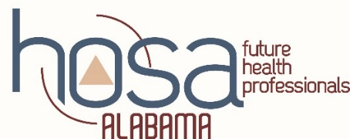

PURPOSE
To recognize advisors for the time and effort they expend to provide successful HOSA chapter activities for their members. To recognize advisors for their active participation in the activities of Alabama HOSA.

GENERAL INFORMATION
The recipient of this honor will be recognized at the HOSA State and International Leadership Conferences during the Recognition Sessions.
All travel and lodging expenses will be the responsibility of the recipient.
*Advisors receiving this award within the last five (5) years are ineligible for nomination

DIRECTIONS
Each nominated advisor will be responsible for completing the application and providing all requested documentation. One advisor will be selected each year.

DEADLINE JANUARY 13th
E-Mail form and requested documentation to:
AlabamaHOSA@alsde.edu
An email response will be sent to acknowledge receipt of application

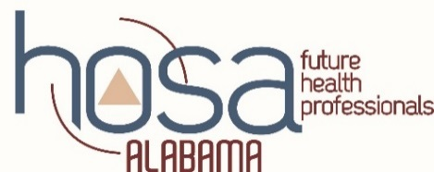
ALABAMA HOSA
ADVISOR OF THE YEAR APPLICATION

NAME

SCHOOL

SCHOOL ADDRESS

CITY/ZIP

WORK PHONE CELL PHONE

ADVISOR HAS:

- Been an advisor of a nationally chartered HOSA chapter for years.

- Taught Health Science for years

- Chaired a State Leadership Conference event times.

- Brought (insert number) students to the previous State Leadership Conference. Total student enrollment last year.

- Total number of students enrolled in your Health Science classes:

- Ran a State Officer times.

- Attended the International Leadership Conference times.

ATTACH DOCUMENTATION FOR THE FOLLOWING:
(May use a bulleted format if desired)

1. HOSA National Service Project
- Provide a description of your chapter’s National Service Project activities.
- Limited to one page, 14 font
2. Describe your chapter’s Program of Work (POW) for the current school term.
- Attach the actual POW
- Briefly describe each community service activity listed in the POW
  - Include the percentage of HOSA students participating in each activity
  - Description is limited to one page, 14 font

Email to alabamahosa@alsde.edu
Email confirmation will be sent upon receipt
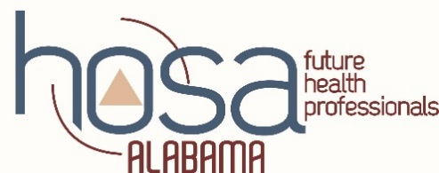
ALABAMA HOSA
ADVISOR OF THE YEAR APPLICATION RUBRIC

Advisor Name:

 | 0  Points | 1  Point | 2  Points | 3  Points | 4  Points | TOTAL
Percentage of years with an affiliated chapter.  (# /years teaching) | NONE | ≤ 49% | 50-74% | 75-99% | 100%
Percentage of times advisor chaired an SLC event.  (# / years teaching) | NONE | ≤ 49% | 50-74% | 75-99% | 100%
Percentage of students brought to previous SLC.  (# brought / # enrolled) | No students attended | 1-15% | 16-30% | 31-49% | Over 50%
Percentage of Years running a State Officer.  (#/years teaching) | NONE | ≤ 5% | 5-24% | 25-74% | 75-100%
Percentage of years advisor attended ILC.  (#/years teaching) | NONE | ≤ 5% | 5-24% | 25-74% | 75-100%
National Service Project Activities (current year) | NONE | One activity; minimal results; not documented in activity tracker | 1-2 activities; minimal – mod results; documented in activity tracker | 2 or more activities; mod -good results; documented in tracker | 2 + activities; good results; documented in tracker; collaborative
POW and Community Service (current year) | NONE | POW not attached; 1-2 Comm. Serv. described; 1-15% participated | POW attached; 1-2 Comm. Serv. described; 10-25% participated | POW attached; 3 + Comm. Serv. described; >25% participated | POW attached; 4 + Comm. Serv. described; >50% participated;
Followed directions | Did not follow directions |  |  |  | Followed directions
TOTAL ______________

