ALABAMA HOSA
DRESS CODE AND BUSINESS ATTIRE
(Revised for Virtual SLC)

Competitive Events:
HOSA members should follow the Event Guidelines in determining appropriate competitive event attire.
For all competitive events, bonus points will not be added per competitor and/or team to the tally sheet for appropriate dress in the virtual setting of this conference, but appropriate dress is encouraged.
Attire appropriate to the occupational area:

This is based on the event. The attire should simulate what an actual professional in the event’s occupation would wear. Jeans and shorts will NOT be acceptable in any event. For example, scrubs are not appropriate for ALL healthcare areas. Safety factors related to certain professions may require different clothing (i.e. CERT).
- Scrubs, khaki pants and polo tops, clinical shoes or tennis shoes are acceptable examples
- Scrubs may be of any color or design, with or without the HOSA emblem
- UNACCEPTABLE examples include denim clothing (any color), canvas shoes, sweats, t-shirts, shorts, short pants, revealing clothing, beach wear, flip flops or thong sandals

APPROPRIATE BUSINESS ATTIRE
- If business attire is identified as acceptable, the competitor can wear any of the following (color is NOT specified)
  - Suits, knee-length skirts or pants with a jacket or sport coat, knee-length dress, HOSA uniform
  - Shoes may be closed or open toed and color is not specified
No policy can possibly cover all contingencies so HOSA members must use a certain amount of judgement in their choice of competition clothing. If you experience uncertainty, ask your advisor. If you remain uncertain, make another clothing choice.

General Session Dress Code policies: use the descriptions below for clarification (based on local chapter advisor’s discretion in virtual conference setting)
SUIT POLICY
- Black or navy-blue suit with a solid white blouse (blouse can be the member’s choice)
- Closed-toe blue or black shoes (hose optional)
- Blue or black belt
- Male members must wear closed-neck, tailored dress shirt with a MAROON or NAVY tie
- Female members may choose to wear knee-length skirt or slacks

HOSA UNIFORM POLICY
- Tailored navy blazer with emblem affixed over the heart
- White, closed neck, tailored* dress shirt, suitable for use with a tie or scarf
- Accent for female members: maroon HOSA scarf
- Accent for male officers: navy or maroon long tie
- Matching navy slacks for males and matching navy slacks or knee-length skirts for females
- Closed-toe blue or black shoes (hose optional)
- Belt (blue or black)
- Head covers required for religious purposes are allowed

PROPER BUSINESS ATTIRE (ALLOWED BY ALABAMA ONLY)
- See description under the competitive events section on page one
(Allowed in general sessions at State Conference ONLY. Will NOT be allowed in general sessions at ILC)
* Tailored is defined as: simple, neat design with fitted lines
DRESS CODE EXAMPLES
HOSA Uniform (Female: with or without the tie)
- 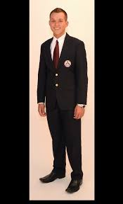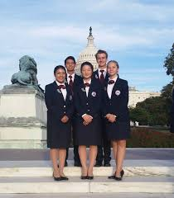
Black or navy, close-toed shoes and belt
Suits
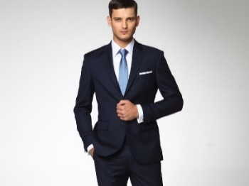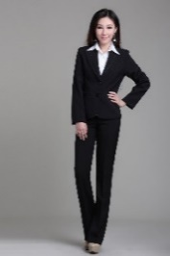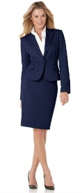
Black or navy, close-toed shoes and belt
Competitive Event Business Attire (ALABAMA ONLY – may also wear in general sessions)
-Tailored dress (no revealing necklines)
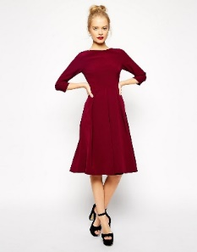
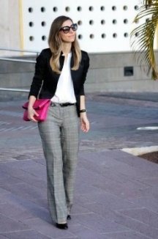
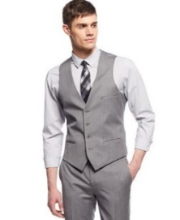
- Business Suits, Jackets/Sport Coats, and Slacks/Skirts
