October HOSA meeting
- Make sure officers have prepared for the meeting
  - Agenda or script
  - Supplies needed
  - September minutes/treasurer’s report
  - Review of old business
  - Review program of work for new business
  - Plan an activity for the National Service Project
    - https://www.bethematchhosa.org/
- Make sure you have submitted your affiliation payment with the invoice to the National HOSA address at 548 Silicon Dr Suite 101 Southlake, TX 76092
a. You can print an invoice right from the national HOSA website. See #7 of the September timeline for affiliation details.
b. All other payments for SQE, SLC, & ILC will go to the AL HOSA Business office at PO Box 1440 Owasso, OK 74055
c. Most advisors ask when the deadline is to affiliate….
i. Make it a goal to affiliate by Oct 15th each year to give your members all the benefits!
- Finalize plans for State Qualifying Events (Registration deadline is November 6th)
  - Who is competing in which event?
    - Competitive Event Resources: http://www.hosa.org/CEUsefulTools
  - Who will Proctor your exams?
  - Where will your students test?
  - Remind students about digital submissions for non-testing events
    - High School & collegiate students will need to create a TALLO account to submit http://www.hosa.org/tallo
    - Tallo profile can be printed out and used for a resume’
    - Please note the change in team events and Tallo submissions- ONLY ONE TEAM MEMBER UPLOADS
    - TALLO uploads have been changed to one pdf single file document upload
    - Middle School students will submit to Wufoo links in SQE registration packet
    - Middle School team events- only one team member must upload
    - Please note that guidelines ask competitors to name the files correctly that they submit!
  - Remind them of the costs ($10/competitor)
  - Through majority vote, determine which fundraisers (if any) you will do (see advisor link on #8 of timeline for fundraiser ideas)
    - You discussed this with the bookkeeper/director for approval last month
  - OR, provide them with a payment plan and a deadline
    - Set the deadline date prior to Alabama HOSA’s deadline for registration submission. SQE registration packet: https://www.alabamahosa.org/resources/
    - Scroll down to State Qualifying Events section
  - Make sure students are also preparing for State Leadership Conference in the event they qualify.
i. Note that National HOSA has added in competitive event sample scenarios into the guidelines that call for scenarios. These should be a great additional resource.
ii. Here is a link to all sample CE scenarios http://www.hosa.org/node/119
i. Competitive Event rubrics are being adjusted for SQE judging and will be sent out soon!
- Make sure your secretary’s minutes include the membership vote on how your chapter’s HOSA monies will be spent (i.e. fieldtrips, competition, state/national dues, local awards, etc.)
  - Many bookkeepers require a copy of the minutes that document the vote on monies. (check your school’s policy)

Send in your chapter’s pin designs
- Each chapter may send in two designs by November 16th
- Great teamwork project that encourages a greater understanding of HOSA
  - Also encourages state pride and knowledge
- Consider collaborating with the art or design classes to perfect your designs (not required)
- Pin Design guidelines are found under State Leadership Conference and the AL HOSA Recognition Awards section at https://www.alabamahosa.org/resources/
- Be creative. The pin does not have to be shaped like the state.
- Winning chapter is recognized at SLC and the design is used on the SLC t-shirts and for the ILC swap pins.

Set up the tracking system for the Barbara James Service Award and the National Service Project on the HOSA website.
A. Member Instructions
B. Chapter Advisor Instructions
i. ALL students that meet the state requirements for recognition can usually attend SLC.
(note: if SLC is a 1/3 socially distanced version recognition event winner attendance at SLC is affected)
  - BJSA: members with 70 approved hours by January 11
  - NSP: chapters with 70 dollars or 70 approved hours by January 11

Enter a student in the State Officer elections
- One student per chapter may run for office
- Review the requirements and get approval from your director
- A State Officer Application, guidelines (REVISED), required dates (REVISED), and duties document are posted at https://www.alabamahosa.org/resources/
under State Officers & Executive Committee State Officer Candidate Resources
  - They should complete it electronically, and upload it on the website
- Follow the directions on the application for submission prior to the due date
  - Due date is Nov 16th
- Don’t be scared to do this, it is a great opportunity for the student AND the teacher. Alabama HOSA incurs the expenses of the officers and many of the advisor’s expenses. (please refer to the requirements section of the application)
- If you have a student that even thinks they MIGHT run for state office, have them take the State Officer exam online during the SQE testing timeframe of Dec 1st-7th.
- If a 1/3 socially distanced SLC is held for 2021, we are working on a format to allow chapters’ voting delegates not in attendance to vote per simply voting.
a. If SLC has to swap to virtual, a video of the candidate’s speech would be required possibly through a zoom session
b. More info to come as needed on this topic….

Request a State Officer visit from a current officer
- Request a visit through the online form at http://www.alabamahosa.org/state-officers#request
- There is NO COST to your chapter. Alabama HOSA covers the expenses.
- A current officer can motivate your students to be more active in HOSA and competition. They can provide leadership advice for your local officers or provide a question and answer session to cover many topics.
- We are providing them in a virtual format this year!

SQE-SLC Update Due to COVID’s Effects
A. The SQE registration packet that was recently released has two new columns of qualifying numbers based on if a required 1/3 socially distanced conference or a virtual conference is necessary.
a. Please know we are in negotiations with the Renaissance/MPAC as to when is the latest time we can commit to the type conference we will hold as it relates to the safety of our members and financial obligations
b. We have attended a “Safe Meetings Open House” with the facilities to ensure they can safely host us with COVID precautions
i. They have temperature screening monitors & Hand Sanitizing Stations
ii. They have a layout for the MPAC to properly socially distance with two seats between each attendee that leads to it only holding less than 600
iii. This meeting led to the 1/3 socially distanced numbers in the SQE packet
iv. The 1/3 number is not 1/3 of the number usually allowed per event. It is 1/3 of the total usually allowed to attend SLC (1/3 of 1800) considering the top 6 per competitive event because some events are team events and that affects the numbers drastically.
v. If we must host the 1/3 socially distanced conference, the recognition event attendees will be limited to only those who place in the top 6 in a competitive event.
vi. All recognition awards will be awarded though and mailed to chapters post conference
c. The trinket item for SLC 2021 will be a HOSA spray hand sanitizer for each registered attendee
d. All CDC/ADPH recommendations in effect in March will be followed if an in-person SLC event is held
B. SQE result postings will be the top 10 and we will ask advisors to declare an intent for their qualifiers similar to how we handle ILC intents in order to ensure we are able to bring 6 in each event to state if a 1/3 socially distanced event is required

Plan HOSA Week!!!!!
- This is always the first full week in November. Set for Nov 1st-7th, 2020 (see attached flyer)
- Great way to market your program
- Plan something HOSA for each day
- Participate in the dress up days that the AL HOSA state officers planned:
Monday Nov 2nd: show your HOSA spirit and wear a HOSA t shirt.
Tuesday Nov 3rd: Health Profession Day. Scrubs are a great idea!
Wednesday Nov 4th: Dress like your favorite superhero!
Thursday Nov 5th: show your support for the Be the Match organization (our national service project) by wearing lime green or light blue or host an event for Be The Match!
Friday Nov 6th: Beach Day!
  - Examples from the HOSA website: http://www.HOSA.org/node/122
  - Work on some of the Alabama HOSA event projects for the recognition events (on the AL HOSA weblink look under SLC/AL HOSA Recognition Awards):
    - Banner Parade https://www.alabamahosa.org/resources/
    - Pin Design https://www.alabamahosa.org/resources/
    - HOSA Happenings Newsletter http://www.hosa.org/guidelines
    - BJSA or NSP http://www.hosa.org/guidelines
    - HOSA Spotlight activities https://www.alabamahosa.org/resources/
  - Provide a health screening for the other students/teachers/ etc.
  - Take your students to the 5th grade classes and teach about “Oral Health through American Toothfairy” or “Germ safety” or “Healthy Living” information (any relevant topic approved by your admin)
  - Send goodie bags/cards/socks to the local nursing home (if allowed due to COVID)
    - Get approval for gifts from the activity director prior to collection
  - Have speakers come in
    - College students in health occupation majors
    - Local health professionals or your local Be the Match representative
    - College admissions recruiters
    - CURRENT STATE OFFICER http://www.alabamahosa.org/state-officers#request
  - Have a proclamation signed by the mayor/superintendent declaring National HOSA Week
    - Notify the paper or take pictures and send the article
    - Take officers to the mayor’s office for the signing/or have the mayor tour the campus and set up the photo op in your classroom
      - Proclamation: 2020 HOSA Week
  - Have a scheduled “Pay it Forward” day
    - Create “you’ve been touched by HOSA today” slips, print on business card paper
    - Leave or hand out these slips when doing an act of kindness for another
    - Have the students discuss the acts of kindness they performed, how it affected the person they were kind to, and how they felt themselves.
    - Encourage them to seek out the students most in need of kindness

Prepare your students for the Virtual JLDC
A. First (early) registration deadline is Oct 16th to receive your chapter swag box prior to JLDC
a. Flat $250 fee for your entire chapter to have access
b. Regular registration deadline is Oct 30th- will receive swag box after Nov 5th
c. Late registration deadline is Nov 6th
d. See attached registration guide for full details
B. Registered advisors have access to JLDC content the whole month of Nov so you can incorporate it into your classes as you see fit
C. CTE+CTSO Sessions will host HOSA specific content for your students
a. All content can be accessed as the scheduled events occur/go live
b. Learn more about how to incorporate our new National Service Project
D. Visit the JLDC website for all the need to know info at http://alabamajldc.org/

9. Useful Information/Updates from our state advisor management conference
- An array of helpful resources for all advisors: http://www.hosa.org/LocalAdvisor
- Students will not be required to show guidelines at SLC, but we all know how important it is that they know them!
- Tallo will now have ILC opportunities that are separate than our AL HOSA opportunities so SLC finalists will all have to re-upload to an ILC opportunity in the non-testing events during the timeframe of April 15th-May 15th.
i. See revised AL HOSA Important Dates Doc attached
ii. Middle School finalists will have new Wufoo forms to upload to for ILC usage
iii. Files that are uploaded should be named correctly as per the guidelines
From the guidelines- Name of file MUST read: school name.state/association.member name.ILC2021
iv. It is fine to name it SLC for the AL submission or SQE, instead of ILC. Just know you will have to re-upload to the ILC Tallo opportunity for ILC finalists and it should be named accordingly for it.
- National HOSA is implementing a “Standards of Excellence” program to motivate all chartered associations to perform at a high level of service
- Remember to promote alumni membership by getting all your seniors registered as alumni. Reach out to former members to register as alumni! http://www.hosa.org/alumni
- Continue to be on the lookout for upcoming HOSA TALL program opportunities: Training for Advisors at the Local Level
- Need a HOSA video? www.hosa.org/video. This year’s ILC promo video is awesome!!
- How to Best Experience Health Professions Week Nov 14th-19th, 2020 ? : http://hosa.org/node/762
- Affiliation Packet for the 2020-2021 School Year – loaded with resources!
- A reminder that student ownership of the organization motivates the members!!

2020-2021 HOSA Theme
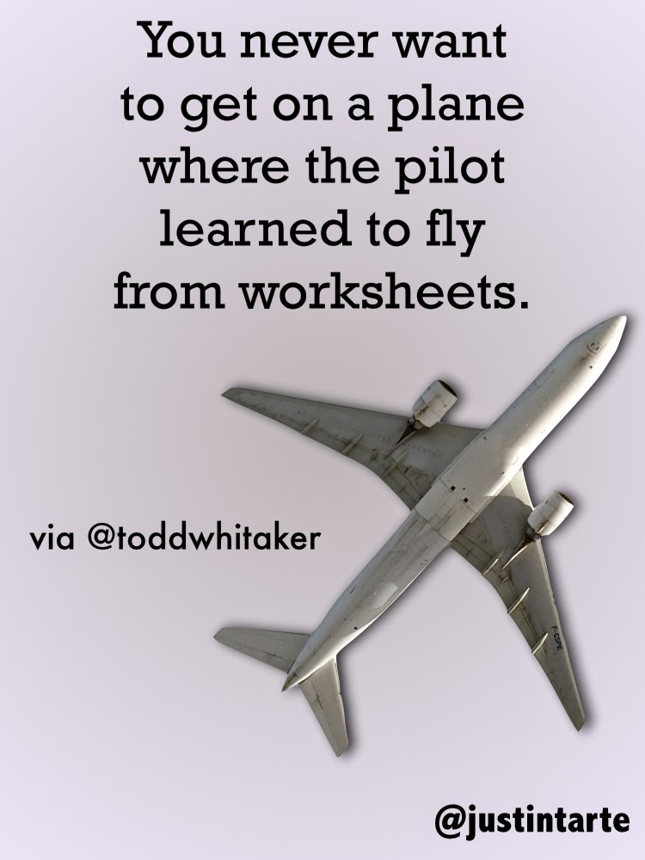
Your 2020-2021 AL HOSA Officers
