November HOSA meeting
- Make sure officers have prepared for the meeting
  - Agenda/script and supplies
  - October minutes and treasurer’s report
  - Review old business and program of work for new business items
  - Continue to plan and complete activities for the National Service Project
    - https://www.bethematchhosa.org/
  - Discuss the State Qualifying Events and resources for final preparations
  - Discuss State Leadership Conference plans to keep students motivated
  - Remind students to update their service hours for the Barbara James Service Award and for the National Service Project in the HOSA Tracking System (you set this up last month)
    - http://www.hosa.org/CEUsefulTools

Implement your HOSA Week plans
- HOSA Week ideas can be found at: http://www.hosa.org/node/122
- A HOSA Week Proclamation can be found at: http://www.hosa.org/sites/default/files/HOSA%20Week%20Proclamation.2020docx.pdf
- Remember our dress-up days for this week that the state officers planned:
Monday Nov 2nd : show your HOSA spirit and wear a HOSA t shirt.
Tuesday Nov 3rd : Health Profession Day. Scrubs are a great idea!
Wednesday Nov 4th: Superhero Day. Dress as your favorite superhero.
Thursday Nov 5th: show your support for the Be The Match organization (our national service project) by wearing their colors, starting a mission, or doing a special project to benefit them.
Friday Nov 6th: Beach Day! Add a beach theme/accessory to your attire. (dress code appropriate of course)
- Have a great time and share HOSA!
- Schedule a state officer visit if you haven’t yet!
- Reminder that the end of HOSA week, Nov 6th, is the deadline to register for state qualifying events.

Recognize Health Professions Week
- November 14-19, 2020
- www.Explorehealthcareers.org/hpw allows you to explore health professions online for free, it will also allow you access to numerous live keynotes, panel discussions, virtual fairs, etc.

State Qualifying Events
- Review your registration for SQE
  - Are all students registered that plan to participate?
  - Are they registered for only 1 event? (Exception: Healthcare Issues Exam/State Officer Candidate)
  - Are all teams numbered correctly? Team numbers should match once they are entered.
  - Do all teams have the correct number of competitors allowed by the guidelines?
  - Reminder to register your state officer candidate for the officer exam.

- Remember all non-testing digital submissions are due Nov 16th.
a. See SQE registration packet
b. State Officer applications are due by Nov 16th also.
c. All candidate resources can be found at: https://alabamahosa.org/resources/ under State Officers & Exec Committee/ State Officer Candidate Resources
i. Please note the application upload is there too!
- Confirm your SQE testing area and proctors for the date(s) you are testing (Dec 1-7)
  - Proctors (with email) should be entered into the HOSA system by you (located in the login area)
See attached screenshot to locate this!
i. Proctors should be identified online & agreements signed by Nov 18th
ii. Proctors should complete the online SQE Proctor Agreement form under Conferences & the State Qualifying Events area at www.alabamahosa.org/resources
iii. You should complete the online SQE Advisor Agreement form under Conferences & the State Qualifying Events area at www.alabamahosa.org/resources
  - Please do not save the testing for the last day. Testing cannot be prolonged because of the tight timeframe before Christmas break.
  - Virtual competitors taking the HOSA competitive event tests should be proctored by the designated proctor through zoom or another platform that your school allows.
- Remind students of testing dates and instructions for SQE submissions
  - Submission requirements and grading rubrics are found in the 2020 SQE Registration Packet & Scoring Rubrics for Non-Testing Events document at www.alabamahosa.org/resources under Conferences and State Qualifying Events.
  - TALLO will be used for all non-testing event and Alabama recognition submissions for high school and college members. Use the TALLO contact information for all submission challenges. http://www.hosa.org/tallo
i. Wufoo submission links are in the SQE registration packet for middle school competitors
  - Non-Testing event competitors must create a profile on Tallo and post their submissions to the correct event for it to be judged!
i. Only one team member is required to submit to Tallo and Wufoo this year. YAY!!
E. Reminder that your SQE payment should be postmarked by November 13th. You can see in the conference registration area of the national HOSA website if your account has been credited with the payment at the top of that screen. See screenshot for what that looks like!
a. You can request a QuickBooks invoice from our business office to pay your SQE fees by credit card if your system prefers
i. Email alabama@ctsofinance.org to request an invoice if you need one to pay by credit card in the next few days.
b. To pay by check you can print an invoice from the HOSA conference management system by looking in the bottom left corner and clicking reports.
i. See screenshot for help on this.
ii. Mail the invoice and the check to our business office in OK- the address is on the invoice.
iii. QuickBooks Invoices will be sent from our business office for all fees not received after the payment postmark date of Nov 13th.

Finalize your state pin design and submit it by November 16th
- We have no submissions so far! I cannot wait to see them all!
- Instructions can be found at www.alabamahosa.org/resources under State Leadership Conference & AL HOSA recognition awards.
- Be creative! Be fun! This design will be used on our SLC T-shirt and will be traded at ILC.

Finalize the paperwork to submit a state officer candidate
- Encourage a budding leader in your classroom
- All state officer candidate resources are found at www.alabamahosa.org/resources under the State Officers & Executive Committee area
- Applications are due by November 16th
- Make sure documents are uploaded to the website under the state officer application upload area or : https://www.alabamahosa.org/state-officer-application/
- Candidates should submit a completed application by Nov 16th. They should also be registered for the state officer exam in the SQE registration system. The candidate will need to test during the Dec 1st-7th timeframe.
- The top 10 scoring candidates on the state officer exam can proceed to SLC as an official state officer candidate and these students and their advisors will be notified by AL HOSA of their candidacy.
- Make sure to register the student for State Leadership Conference (SLC) once registration opens, indicate they are a State Officer Candidate under the options.
- Have the student prepare a brief speech detailing why other students should vote for them. They might include topics such as:
  - What does HOSA mean to them?
  - What other leadership experience do they have?
  - What is their vision for Alabama HOSA?

Make sure students are working on their scholarship applications
- Application can be found at www.alabamahosa.org/resources under SLC & AL HOSA Recognition Awards
- Application is submitted by uploading the document to TALLO

Make sure you have affiliated all members through the HOSA website before November 6th (SQE registration is due November 6th )
- Additional members can be affiliated at any time throughout the year, but members must be affiliated before you can register them for any event.

State Leadership Conference (SLC) preparation
- Students that qualify to go to SLC will be posted on the website as soon as possible after SQE
  - The SLC registration packet will be uploaded to www.alabamahosa.org/resources under the Conference area and State Leadership Conference.
  - Also look for these items that will be uploaded soon to our AL HOSA website!
    - SLC Code of Conduct
    - SLC Schedule
    - Downtown Montgomery Map
    - Event Dress Code
  - As a reminder… we will be making the decision regarding our conference format due to COVID precautions by Dec 15th
- Register students for SLC through the National HOSA website, registration will open after SQE qualifiers are posted
- Participate in the State Events: HOSA Spotlight and the Banner Parade (guidelines are at www.alabamahosa.org/resources under the AL HOSA Recognition Awards section)
- Participate in HOSA Happenings (good assignment for your historian/reporter), guidelines are on the National HOSA website under Competitive Events Guidelines: www.hosa.org. Our Alabama submissions will be completed through TALLO.
- Nominate a worthy advisor for Alabama’s “Advisor of the Year” or a worthy member for the “Member of the Year” (applications found at www.alabamahosa.org/resources under AL HOSA Recognition Awards)
  - To nominate an advisor, send the advisor’s name and school to alabamahosa@alsde.edu with a brief paragraph explaining why they are nominated prior to January 11th.
  - To nominate a student, complete the form and send it to alabamahosa@alsde.edu
- Make sure you set aside time to help prepare the students for their competitions
Suggestions:
  - Assign one day each week to HOSA preparation
  - Contact other health professionals and schedule time after school hours for them to help your students
  - Schedule practice after school hours
  - Have alternate activities for the students that are not scheduled to attend (for example: creating health posters on a given topic – you can use the middle school extemporaneous poster rubric or check out the new research poster guidelines)
- Prepare for future competitions as you prepare for this one
  - Create a file box with a file for each competition
  - As you/your students create tests, flash cards, etc. add them to the appropriate file
  - Keep an index card in each file that lists web-based resources
  - Keep an index card in each file that lists resource people willing to help your students with competition (i.e. dental hygienist, EMTs)
- Continue to fundraise if needed
  - http://www.hosa.org/sites/default/files/2014%20Fundraising_0.pdf#overlay-context=node/110
- Remind students of the DRESS CODE for SLC and make sure they have read the guidelines for their competition’s dress code.
- You can give a HOSA Guidelines Test to make sure they read the guidelines. (give 5 bonus points to each student that shows you their guidelines at test time)
  - Possible questions
    - What must you bring to your event?
    - How do you know what you must bring to your event?
    - What is proper attire for your event?
    - Name at least one official reference given for your event.
    - What category does your event fall under?
    - Does your event include a test?
      - If so, how long do you have to complete the test?
      - How many questions will be on the test?
      - Which topic is responsible for the largest percentage of test questions?
    - Does your event include skills?
      - If so, list the skills you must know for your event.
      - How many of these skills can be included in your event?
    - How many people can compete with you in your event?
    - How many rounds are in your event?
    - Where are the guidelines located on the website?
    - What must you complete for the State Qualifying Events?
K. HOSA SLC Hotel information:
a. The Renaissance Montgomery Hotel & Spa is the conference hotel
i. You can call the Renaissance Montgomery and ask for rooms within the AL HOSA Future Health Professionals Conference for your reservations. 334-481-5000 or 1-877-545-0311
ii. There are several other surrounding hotels.
b. RESERVATION LINK INFO:
Here's your reservation link your guests can use to make reservations:
Book your group rate for HOSA Future Health Professionals Convention
You will find the information for your online reservation link below. If you have questions or need help with the link, please do not hesitate to ask. We appreciate your business and look forward to a successful event.
Event Summary:
HOSA Future Health Professionals Convention
Start Date: Sunday, February 28, 2021
End Date: Monday, March 8, 2021
Last Day to Book: Tuesday, February 2, 2021
Hotel(s) offering your special group rate:
- Renaissance Montgomery Hotel & Spa at the Convention Center for 140 USD per night
Book your group rate for HOSA Future Health Professionals Convention

10. Complete Your JLDC Registration (if you haven’t already) & Participate in the Event This Week or On Demand After This Week!
A. Deadline for registration is Nov 6th.
B. All the need to know info can be found here: https://www.alabamajldc.org/
C. Registered chapters were emailed from info@alabamajldc.org a virtual learning guide and a Teacher FAQ & guide in the last day or so with all the details to navigate the virtual event.
D. Access/login information for the conference will be emailed Thursday morning prior to the first session.

Sample Health Career displays are found below
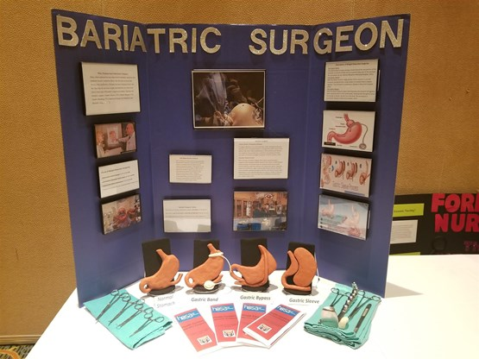
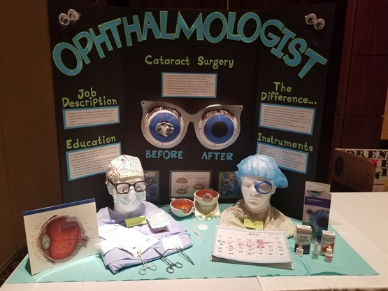
More CE samples are in the photo gallery at www.alabamahosa.org & http://www.hosa.org/node/119

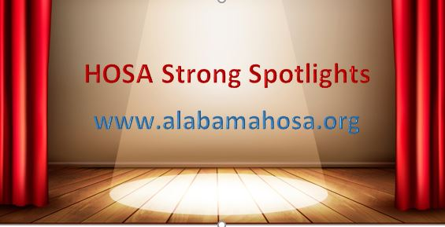
2020-2021 National HOSA Theme

