Make sure you have reviewed the 2020 Summer Conference HOSA Update for the most need to know info for the school year!
2020 HOSA Summer Conference Update
II. Print the HOSA Important Dates document attached to this email and add events into your calendar for planning purposes

III. Introduce students to HOSA during the first weeks

Describe
- HOSA’s purpose
- How the meetings will be conducted
- Officer elections
- Competition
- Community service
- Dues required (make sure you have reviewed National/State dues for changes)- $20 per member this year!

IV. Set a deadline for dues

The deadline should be before your officer elections

Consider if the payment of the dues will be a different process this year with your students who are virtual and see what your bookkeeper advises regarding payment acceptance.

Decide if students will pay on their own, get sponsors, or pay by participating in a fundraiser

Fundraising ideas can be found on the HOSA website at http://www.hosa.org/sites/default/files/2014%20Fundraising_0.pdf#overlay-context=node/110

If fundraising for dues, make sure you talk to your director and bookkeeper for approval and the correct procedures for your school.
F. Our affiliation instructions can be printed from https://www.alabamahosa.org/resources/ membership & affiliation section

V. National HOSA has updated their affiliation and conference management system! https://apps.hosa.org//

A. Very similar to the original one, but with some new features like--- your school can pay your affiliation dues on the site now with a credit card if you prefer ($2.70 fee incurred).
B. As the state advisor, I cannot see all the chapter’s login information in case you lose your password, but there is a forgot password link that is linked to the advisor’s email.
i. We can also reach out to National HOSA for the login and receive new chapter/advisor logins through them
C. Email is a required field now for all members to be affiliated
i. It still recalls all previous members, so you can easily check the ones to continue their membership
D. There is a “quote” page you can print before submitting so you have a document to provide to your bookkeeper before finalizing the application.
E. You can come back and pick up where you left off on the affiliation process
F. There should be a video tutorial for local advisors coming soon for use of the system
G. You can export a list of your members as needed
H. You can now view past conference registration info
I. Screenshots of some features are in the final pages of this timeline

VI. Plan a short meeting to nominate officers

A. Review the duties of each office before opening the floor for nominations

B. It is less chaotic if you do nominations for one office at a time

C. There are several ways to do this, suggestions below:
ONE

Students raise hands and wait to be recognized

Student nominates a person; you ask if there is a second (any student can second the nomination)

Address the nominated students and ask if they accept the nomination

If they accept, add that name to the list of nominees

When there are no more nominations, close the nominations for that office and open the floor for nominations for the next office
TWO - Could also convert this into a google/wufoo form format
- Provide each student with a paper listing each office and have them write the name of any student they feel would be good in that position
- You combine this into a master list of nominees and ask the nominees if they accept the nomination
- This works better when there is limited time for a meeting. This can be done in class the day before the actual meeting.

VII. Set the date of officer elections

You can use other methods of electing officers, the instructions below are suggestions, not mandates)
Consider adaptations needed for virtual format like a video recording of their “campaign speech”

A. Each officer should be allowed 1-2 minutes before the members to state why they would be best in the office for which they have been nominated.

B. Stress in advance, NO NEGATIVE CAMPAIGNS

1. HOSA embodies tact and caring, speaking negatively about another member does not reflect the goals of the organization.

C. Vote on each office after all campaign speeches are complete

1. Vote by secret ballot
- Collect votes in a box after each office (COVID-19 precaution- swap to online voting per google form)
- Or, have them list the names of each office on one paper, write their vote beside each office and turn in the paper after all campaign speeches are complete.
- Or, (if you have access to this) use the response buzzers, but keep the screen where you are the only one that can see the responses.
- Or do it by Google docs, or use an online survey site such as SurveyMoz or SurveyMonkey.

VIII. Set the date of the next HOSA meeting and install the officers

A. Sample installation ceremonies can be found at the link below, at http://hosa.org/LocalAdvisor at the officer installation ceremony tab and in the New Advisor’s Handbook. Samples will also be found on the www.AlabamaHOSA.org website at https://www.alabamahosa.org/resources/ under templates & ideas (These installation ceremonies all contain wording referring to the old emblem, you will need to change the wording in those sentences for this year. As HOSA comes out with the new samples we will replace the links)

1. Make sure you have the supplies for the ceremony you choose

B. Cover the basics of how meetings will be conducted, expected member behavior, and competitive event opportunities. Make sure the members know to come to the next meeting with community service and speaker ideas. (You will be creating your chapter’s program of work: the chapter goals and how your chapter will accomplish the goals you set)

C. Make sure each officer is aware of their duties.

1. Plan the agenda and process for the next meeting
- What will be covered?
- Who will cover each part?
- How will the members vote? (especially in relation to COVID precautions)
- Will you use a meeting script or just an agenda?
2. Discuss the Program of Work
3. The secretary will need minutes of the installation ceremony
D. Plan some icebreakers and teambuilding exercises to create a cohesive organization.

IX. NEW RESOURCES for HOSA Classroom Activities & Lesson Ideas!!
A. Virtual On-Demand Learning Opportunities found here: http://www.hosa.org/OnDemandLearning
CHECK THIS OUT!!

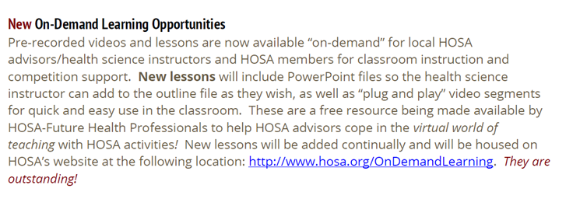

X. Youth Advisory Board Opportunity

A. Catch My Breath Youth Advisory Board Info
B. Interested youth in both middle & high schools should submit application by Aug 21, 2020

XI. Think ahead to upcoming events

A. JLDC (Joint Leadership Development Conference) Updates will be posted here as they arise http://alabamajldc.org/

1. Leadership topics and motivational keynote speakers

2. December dates tentative….

B. Competitive Events
3. The new national competitive event updates for this school year will be released in September http://www.HOSA.org/guidelines
4. The Alabama HOSA competitive events list is at https://www.alabamahosa.org/resources/ under conferences and SLC or SQE

There are separate event lists for secondary/post-secondary and middle school. Make sure you are looking at the correct list.

5. Our State Qualifying Events will be held in the fall semester so notice the deadlines for those Nov 16th online submissions & Dec 1st-7th for testing events. Documents for these events will be added to the https://www.alabamahosa.org/resources/ SQE section page soon.

6. State Leadership Conference: March 4th & 5th,2021 in Montgomery (will update you on any plan to swap to virtual approx. 3 months in advance)

7. International Leadership Conference: June 23-26, 2021 in Orlando, FL

8. National Service Project: Be The Match https://bethematch.org/

9. New HOSA Theme: Unlock Your Potential
http://www.hosa.org/brand

XII. Washington Leadership Academy UPDATE:
A. WLA is being transformed into GLA, Global Leadership Academy, due to COVID-19
i. As of now, it is only being made available to state executive council teams
ii. More info to come at http://www.hosa.org/WLA

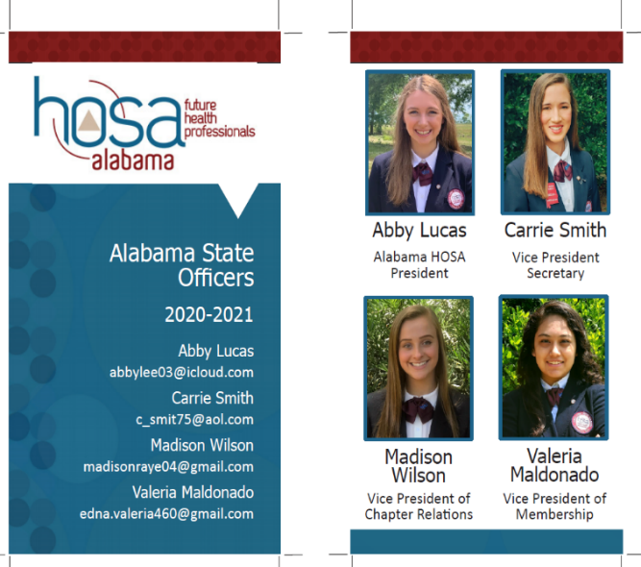
XIII. Request a virtual state officer visit for your chapter

A. Workshops tailored to your needs.

B No charge to your chapter
C. https://www.alabamahosa.org/state-officers/#request

