2020-2021
ALABAMA HOSA EXECUTIVE COMMITTEE

State Office Address: HOSA Business Office Address:
Alabama Department of Education Alabama HOSA Business Office
Health Science Education/HOSA PO Box 1440
P.O. Box 302101 Owasso, OK 74055
Montgomery, AL 36130-2101 *All Alabama HOSA financial transactions/inquiries
Phone: 334-694-4766 Phone: 334-450-2723
Email: alabama@ctsofinance.org

State Staff:
Dana Stringer, Education Specialist and Senior HOSA State Advisor
Personal Cell: 334-322-4988
E-Mail: dstringer@alsde.edu

Becky Cornelius, Education Specialist and HOSA State Advisor
Personal Cell: 334-429-4034
E-Mail: rcornelius@alsde.edu

Nancy Prine, Education Administrator
Office Phone: 334-694-4767
E-Mail: nancy.prine@alsde.edu
President | 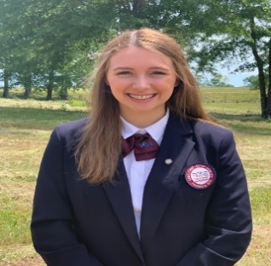 | Abby Lucas  abbylee03@icloud.com | Laurie Osborne  ldosborne@auburnschools.org | Auburn HS  405 S Dean Rd Auburn, AL 36830  (Lee County)
First Vice President/ Secretary | 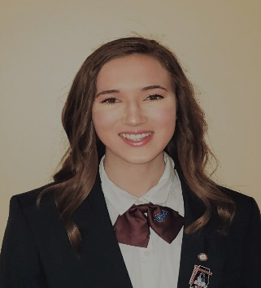 | Carrie Smith  c_smit75@aol.com | Jennifer Walworth  jewalworth@dothan.k12.al.us | Dothan Technology Center  3165 Reeves St.  Dothan, AL 36303  (Dale County)
Vice President of Chapter Relations | 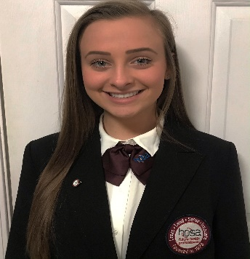 | Madison Wilson  madisonraye04@gmail.com | Chelsea Humphres  chumphres.hhs@mcbe.net | Hamilton High School  211 Aggie Ave.  Hamilton, AL 35570  (Marion County)
Vice President of Membership |  | Valeria Maldonado  edna.valeria460@gmail.com | Laken Raper  laken.raper@franklin.k12.al.us | Red Bay High School  800 8th St  Red Bay, AL 35582  (Franklin County)

2020-2021
Alabama HOSA Executive Committee

